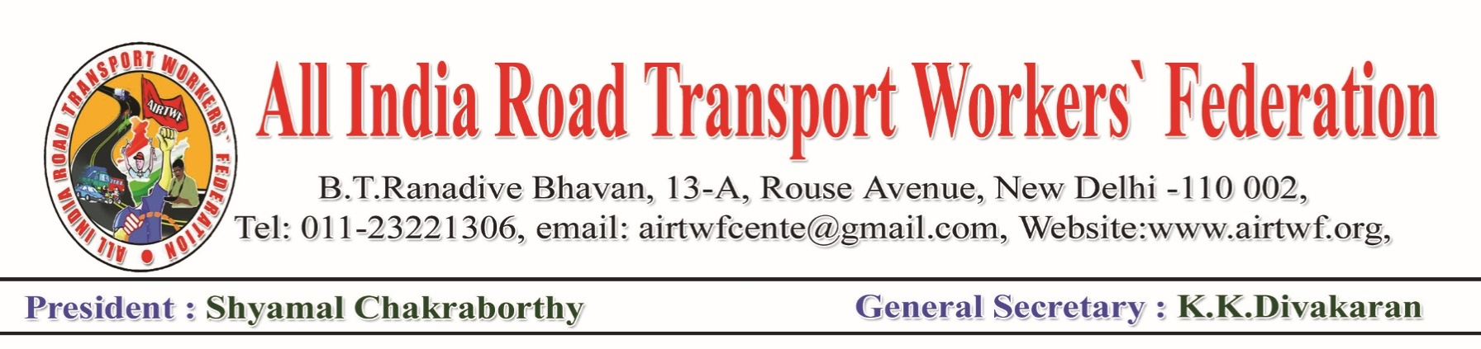Press Release: Date:06-05-2020

All India Road Transport Workers’ Federation strongly condemns the union Government’s decision to hike the prices of Petrol and diesel Rs.10 and 13 per litre respectively. AIRTWF demands the Goveernment to roll back the hike forthwith. This is nothing but looting the people. At a time when peo[ple are put in lockdown and suffering a lot for their survival as they do not have any earnings. When the entire world is seriously effected by the COVID 19, almost all the National Governments in the world are extending financial help to the people in a big way, the union Government of India is burdening the people heavily. This shows the cruality and onslaught on the ppeople by the Government. AIRTWF appeals to all the affiliated unions and all the stake holders to express protest duly following the lockdown norms.

The prices of Crude Oil in the international market are slashing drastically. The union Government instead of reducing the prices of Petrol and Diesel proportionately enhancing the duties and filling the treasury of the Government at the cost of the people. The abnormal increase of petrol and diesel prices will have cascading effect on all the items as the transport charges goes up. This will add fuel to the sufferings of the people.

Even before the COVID 19, the transport industry in the country is in serious crisis. The COVID 19 and the too long period of lockdown further ruined the industry. Majority of the commercial vehicles such as Auto Rikshaw, Taxi, Truck, Private Bus etc are owned by petty owners. They have to be exempted from all the taxes, permit feeses, Toll Charges etc. But nothing is done by the Government to rescue the petty owners. In contrast, it is burdening them heavily.

Considering the facts and ground reality,AIRTWF demands the union government to roll back the hike and reduce the prices of Petrol and Diesel in proportion to the international market prices.



(K.K.DIVAKARAN)

General Secretary