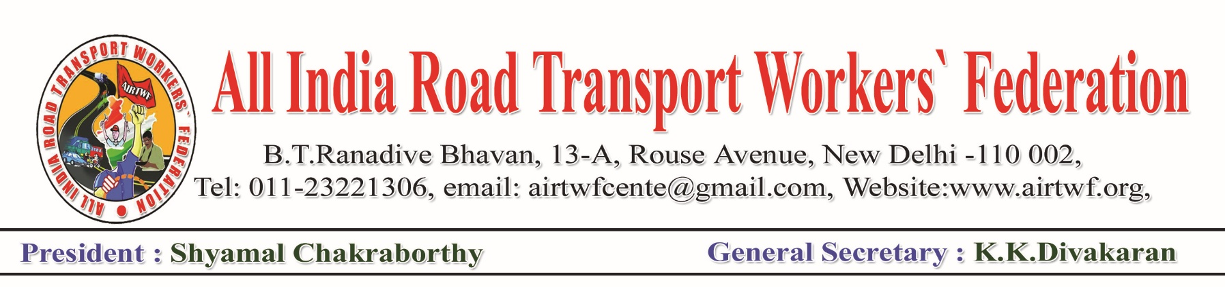To, Dated: 19-04-2020

Shri. Nitin Gadkari Ji,

Honourable Minister ORTH,

Government of India,

New Delhi.

Respected Sir,

Sub: COVID 19- Lockdown- Collection of Toll fee wef 20-04-2020-Request to

Withdraw-Regarding

We would like to draw your kind attention to the order for collection of Toll fee from 20-04-2020. It will further aggravate the financial burden of the Truckers. Hence it is requested to withdraw forthwith and issue orders directing the concerned authorities/agencies not to collect Toll fee at least for another three months.

It is not out of place to mention here that most of the Trucks are owned by petty owners having one or two vehicles. Even before the COVID19, the Truck industry in the country is in serious crisis. The cost of operation has multiplied and the revenue has come down. Most of the vehicle owners are not in a position to pay the monthly instalments to the finance companies from whom they borrowed for the purchase of the vehicle. A large number of vehicles are seized by the Finance companies for default of EMIs payment. The COVID19 Pandemic and the lockdown added fuel to the crisis and the industry is on the verge of collapse. At this juncture, if Toll collection starts from 20-04-2020, the petty Truck operators will be compelled to stop the operation of their vehicles. This will create a huge shortage of essential services and panic which should not happen at this crucial time.

In the light of the above-mentioned ground reality, your good self is requested to issue orders for suspension of collection of Toll fee at least for another three months.

We hope, you will respond positively and issue orders to that effect.

Copies submitted to:

Honourable Finance Minister & Home Minister



(K.K.DIVAKARAN)

General Secretary