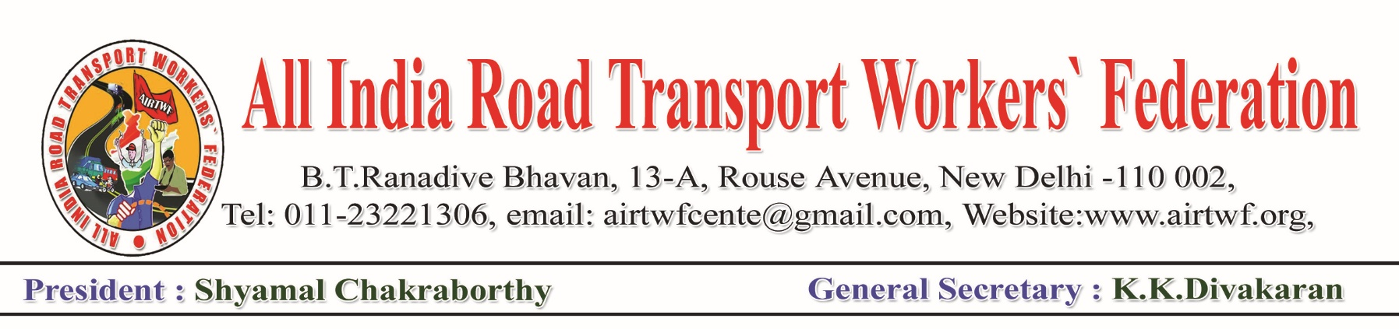To, Dated: 23-04-2020

Shri. Nitin Gadkari Ji,

Honourable Minister ORTH,

Government of India,

New Delhi.

Respected Sir,

Sub: COVID 19- Lockdown- Certain problems faced by the petty vehicle owners

& transport Industry- Request to take suitable decisions with immediate

effect Regarding.

Ref: Our earlier representation dt:13-03-2020,30-03-2020,21-03-2020 and

19- 04-2020 to your authority.

Our representation to honourable Home Minister, dt.03-04-2020

Our representation to honourable Finance Minister, dt.13-04-2020.

We would like to draw your kind attention to the order for collection towards our earlier representations as cited under reference time to time on different issues of Transport Industry and the petty operators. We put forth before you the following demands while summarising the earlier representations and request your authority to pay immediate attention to resolve the issues and issue necessary orders to the concerned.

1. The Crude Oil prices have crashed drastically in recent times. Surprisingly, now reverse trend started to pay to the buyers instead of sellers. It is very painful to mention that prices of Petrol, Diesel etc have not been reduced in accordance to the international prices. Hence, we request you to utilise your good offices with the Petroleum and Finance Ministers to bring down the rates.
2. M.V.Tax, Toll Charges be suspended for 6 six months from 01-04-2020 and adjust to future to those who have already paid.
3. Insurance premiums shall also to be suspended from 1st April to 30th September 2020.
4. The unorganised Transport workers shall be paid @Rs.7500/ per months for at least 3 months. The Small and medium transport operating companies (legal operators) shall be extended financial assistance to pay salaries to the workers and to resume normal operations after the lockdown is relaxed.
5. Even after the lock down is relaxed, normal operation of passenger vehicle may not take place as per seating capacity due to physical distance maintenance norms. Hence the petty operators are to be extended financial support to what extent they forgo (as per seating capacity) in observing the rules.

We once again request you to please consider the above most crucial and burning issues and issue necessary orders.



(K.K.DIVAKARAN)

General Secretary