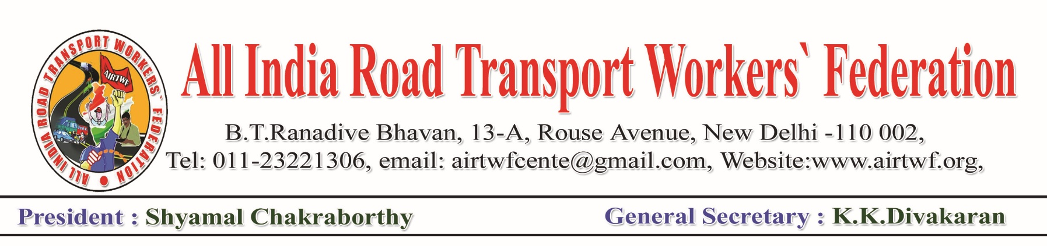To, Dated: 06-04-2020

Smt. Nirmala Sitaraman,

Honourable Finance Minister,

Government of India,

New Delhi.

Respected Madam,

Sub: COVID 19- Problems of Transport vehicle owners during Lockdown &

COVID 19- Request for your intervention and for necessary orders.

We would like to draw your attention to your announcement with regard to moratorium on borrowings due to COVID 19 and lockdown. Your authority has rightly taken a decision on payment of EMIs on borrowings to be differed till June 2020.

We would like to bring to your notice that almost 90% of small Commercial vehicle owners like Auto Rickshaw, Taxi, Truck are either owners of one or two vehicles. Most of them have borrowed from Private Financial institutions for the purchase of vehicles. But the Private Financial Institutions are insisting for regular payment of EMIs saying that the decision of the Finance Minister is only for Public Sector Financial institutions and it is not binding on Private Financial institutions. This has become a serious problem as the vehicle owners cannot operate their vehicles due to complete lock down and even before the lockdown also the movement of public has fallen drastically due to COVID 19. At this juncture the petty owners are unable to pay the EMIs till the normalcy is restored.

Hence it is requested to issue necessary instructions clarifying that the moratorium is binding on Private Financial institutions also.

Further, even the Public Sector Financial institutions are saying that interest for the moratorium period shall also be paid along with the EMIs later. This will also be a heavy burden on the petty vehicle owners. Hence you are requested to issue necessary instructions that interest for the moratorium period shall not be collected.

Another serious problem is that the payment of quarterly tax for the trucks. All most all the truckers have already paid the quarterly tax in the month of March for the quarter starting from 1st April. But from 25th March itself complete lockdown is imposed. Even before that also the business was badly affected due to COVID 19 and it may take even more longer period for restoration of normalcy.

In some states the Auto Rickshaws are exempted from M.V. Tax. But in many states, it is being levied either quarterly or yearly. For the Taxies there is no exemption from M.V.Tax

It is a fact that the issue of M.V.Tax is vested with the State Governments. But the current challenges are to addressed at national level.

Hence your good self is requested to direct the state Governments to treat the quarterly tax already paid for the quarter April – June as paid for the next quarter ie July-September. Further, the quarterly tax for January -March which was already paid shall be adjusted against the October-December quarter in case of Trucks. For Auto Rickshaws and Taxies also, the same relaxation shall be allowed as per the taxation system.

It is humbly requested to consider the above issues and necessary instructions may be issued accordingly.



(K.K.DIVAKARAN)

General Secretary