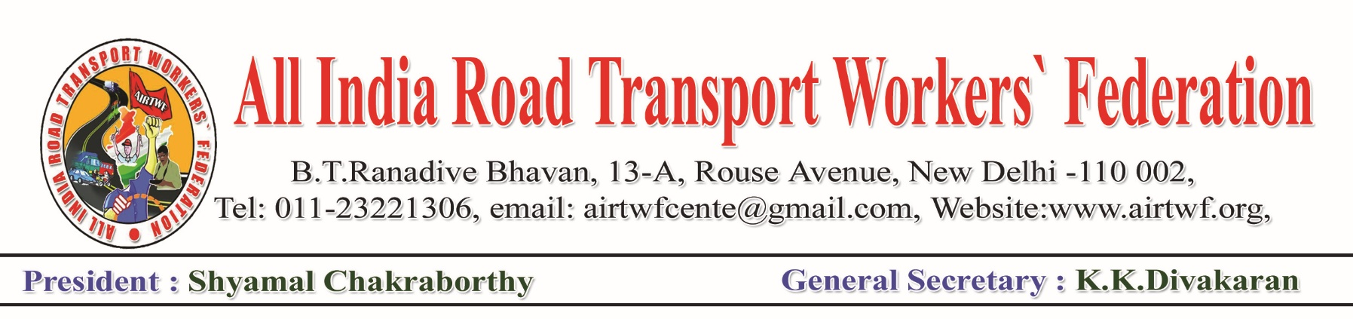To, Dated: 03-04-2020

Shri. Amit Shah,

Honourable Home Minister,

Government of India,

New Delhi.

Respected Sir,

Sub: COVID 19- Problems during Lockdown- Requested for

intervention.

It is humbly submitted that the Haryana State Government has ordered the Haryana Roadways to operate some buses exclusively to take the migrant labour to their native places in UP state. Accordingly, the authorities ordered the crew to operate nearly 1000 buses. But ironically one Driver Mr.Kursheed Ahammad, bus no. HR-38-0501 of Palwal Depot, was badly beaten by the Police personal at Carabani Chowk, Lucknow in the midnight on 30-03-2020. The driver was seriously injured.

In another incident it is reported in the press on 02-04-2020 that notices were issued to DTC for operating buses to transport the migrant workers. These are the political decisions. Those decisions ought to be honoured and implemented with true spirit by the Public Sector Undertakings. Haryana Roadways workers and DTC have discharged their responsibilities at the directions of the respective state Governments. At this juncture, beating the driver and issuing notices to DTC are highly condemnable.

Further, even after clear instructions to allow goods vehicles without any restrictions, the drivers at some state boarder places are being humiliated and tortured by the police personals not allowed them to proceed. Some goods vehicle drivers complained to our Office that after unloading the material at the requisite palaces, the empty vehicles are not allowed to reach their home town/places. This is also against the rules.

We request your authority to intervene in the above stated issues and issue suitable instructions to the concerned that the workers, PSUs and the drivers shall not be made responsible/tortured and they shall be allowed to discharge their functions peacefully.



(K.K.DIVAKARAN)

General Secretary