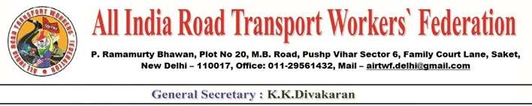

# To, Date: 23-12-2021

Shri. Nitin Gadkari ji, Honorable Minister, MORTH,

Govt. of India, New Delhi.

Respected Sir,

Sub: Representation- Submission of representation for

redressal of grievances-Requested-Reg

We would like to draw your kind attention to the serious crisis being faced by the Transport industry and the workers both in goods transport and passenger transport. Even before the Covid Pandemic, the industry was in crisis. The Pandemic, lock down/restrictions have further worsened the situation. Even today, a good number of Auto Rickshaws, Taxi owner cum drivers could not run their vehicles due to low potential. According to one assessment 30% of the trucks(lorries) are off the road. Petty owners are not even in a position to pay the monthly EMIs to clear the vehicle loan. This situation has led to suicides in some parts of the country. Situation is very grim.

The unorganized Road Transport Workers are not covered by any labour legislation. Minimum wages, weekly day of rest, ESI, PF etc are the nightmare to these workers. It is very heart burning to mention that the recommendations of V.V.Giri National Labour Institute for enactment of Welfare Act is unheard till date.

The attacks on the drivers are increasing day by day by the anti-social elements, terrorists etc. Some drivers were even killed by them. Hijacking the vehicles and looting the money and material are often taking place. At this juncture, we have organized a national convention of the Unorganized Road Transport Workers in Delhi. A declaration was adopted in the convention requesting the Government to resolve the following issues.

Demands:

1. Supply Food grains @10 kgs per person till March 2022 without insisting Ration Card.

Contd… 2

-2-

1. Payment of Rs.7,500/ per month to all the unorganized Transport workers till March 2022.
2. Withdraw enhanced excise duty levied in the year 2020 on Diesel/Petrol and roll back the enhanced prices by the Oil Companies since 07th June 2020.
3. Bring Petrol & Diesel under the purview of GST duly compensating the loss of revenue to the states.
4. State Governments should make arrangements for loan through Nationalized Banks for purchase of new vehicles to the self-employed.
5. Steps shall be taken to control the harassment by the Private Finance Companies.
6. Insurance premiums are enhanced irrationally by the IRDA. It should be controlled and Trade Union representatives also shall be included in the Committee. Transparency shall be maintained.
7. Enact Social Security Act for the unorganized Transport Workers as recommended by V.V.Giri National Labour Institute. Suitable amendments to labour laws shall be brought so as to be applicable to even a single worker and for the appointment letters by the owners.
8. Withdraw the Amended M.V. Act 2019 and discuss with all the stakeholders for a better and proper alternative policy.
9. Withdraw anti Working-Class Labour Codes.
10. All the unorganized Road Transport Workers including self-employed shall be recorded in the registers of labour Department.
11. All the unorganized Road Transport Workers including self-employed shall be covered under all the labour laws. Suitable amendments shall be brought accordingly.
12. Harassment of Police and other Officials should be stopped forthwith. 14.Security arrangements shall be made to stop attacks on the

workers. If any Road Transport Worker is killed by the extremist/anti-social

elements, Rs.50,00,000 compensation shall be paid to the family of the deceased by

the respective Governments where such incident took place.

1. Drivers attached to App based companies like Uber/Ola shall be considered as their workers. Suitable amendments are to be made in the M.V.Act/M.T.W.Act.
2. The Drivers and cleaners working on oil Tankers through the contractors shall be paid minimum wages, PF, ESI, Gratuity, etc. The Oil companies shall be held responsible for the implementation. This clause shall be incorporated in the agreement entered in to with the contractors.

Contd… 3

-3-

1. The profession of Driver shall be treated with dignity and respect.
2. Transport Workers who succumbed to death, the family members shall be paid Rs.50,00,0000 insurance.

We hope, you will respond positively.

Yours sincerely

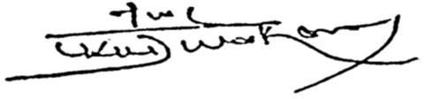

(K.K.DIVAKARAN)

General Secretary

Copies submitted to for favor of information and necessary action.

1) Honorable Minister for Finance

2) Honorable Minister for Petroleum & Natural Gas

3) Honorable Minister for Labour & Employment

4) Honorable Minister for Home Affairs

5) Honorable Minister for Health & Family Welfare